A message from our Principal

Dear Parents & Carers,

The year has just flown by and we are now down to only 4 weeks before the end of term. This is a really hectic time of year and we will be putting out information on Graduation and Book Award assemblies as soon as we have finalised the arrangements as we need to ensure that we are operating within the COVID19 guidelines.

I would like to thank all of our parents for the support that they have given us in regards to ensuring that our students wear helmets when riding scooters and bicycles as this is a law since 1993. There are also fines that can be given by police if this law is not complied with. It is really important from a safety perspective as head injuries are more common than we think when accidents happen.

We are exploring whether we qualify for a traffic warden and I would like to thank those parents that have volunteered to assist me with this process. We will be completing this over the next few weeks and I will provide our community with information when this is completed.

I would like to thank our HASS team capably led by Mrs Zanoli and Mrs Cross for their organisation of our NAIDOC Week events. The students participated in a range of activities and our Year 4 students plus a few selected students took part in a range of cultural activities with staff from the Djinda Bridiya Wellbeing Australian Aboriginal Corporation. The students had a wonderful time learning some important facts about Aboriginal culture and the importance of some of their ceremonies, such as the Smoking Ceremony. As part of the work undertaken four students will be attending the official launch of the Alkimos Central development where our children’s art will be displayed.

We have had the Alkimos Pirates Lacrosse Club here this week instructing many of our students in the rules and playing of this game. The students have thoroughly enjoyed and Mr Innes is working on having some follow up sessions for our students in this sport.

Just to note, we have had some community feedback about some of our students acting inappropriately at the fitness park. Please remind your children that they are representing the school if they are at the park in their school uniform.

Have a wonderful fortnight everyone!

Michelle Wellsteed
Principal

Michelle Wellsteed
Principal

Have a great fortnight everyone!
Michelle Wellsteed
Principal

z
Term 4, Week 6 2020

Term Dates
2020

Term 1
Mon 3rd Feb –Thu 9th Apr

Term 2
Tues 28th Apr-Fri 3rd Jul

Term3
Mon 20th Jul–Fri 25th Sept

Term 4
Mon 12th Oct-Thu 17th Dec
School Development Days

Term 1
Thur 30th January, Fri 31st January

Term 4
Thur 29th October, Fri 30th October, Fri 18th December

200 Leatherback Boulevard
Alkimos WA 6038
Phone: 08 9561 7200
Website: alkimosps.wa.edu.au

SCHOOL VALUES

These are really important at the moment for all of our community. Resilience is the key for all of us to get through tough times. One of the critical values to remember is:
Tolerance and Inclusion

Meaning: Welcome different opinions or behaviours that one does not necessarily agree with

Synonyms: allow, involve, embrace, patience, resilience

You are practicing TOLERANCE AND INCLUSION when you:
- Treat people in a way they wish to be treated.
- Welcome ideas that are different from your own, it can also make work more interesting, engaging and fun.
- Strive to improve. Be willing to learn, accept feedback, and listen to the concerns of those around you.
- Are culturally aware. Take the time to learn about different cultures, races, religions and backgrounds.

MISSING NECKLACE
A necklace went missing from the K/PP area on Tuesday 10th November. Please contact the school if you have any information.

JAPANESE NEWS

Students in Year 5 and 6 have celebrated mastering the skill of reading and writing of the hiragana characters (basic Japanese alphabet) with a handwriting task using pancake mix. Each colour represents the correct order to write each line. Year 4 students are excited that they will have their turn at this lesson very soon. Hopefully more students will be skilled at cooking yummy pancakes for a family breakfast at home.

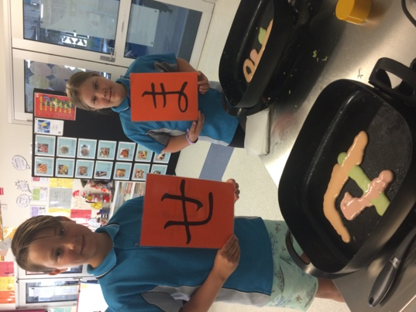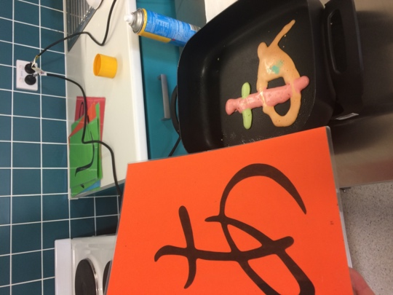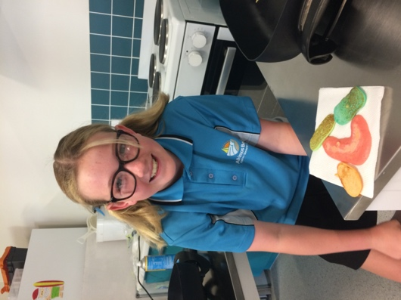
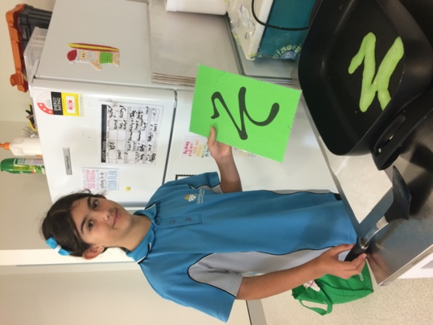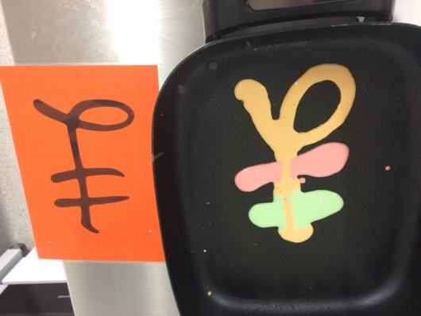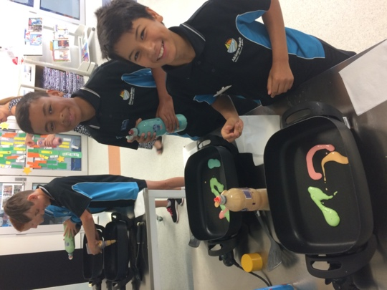
ALKIMOS COMMUNITY ART HOARDING PROJECT

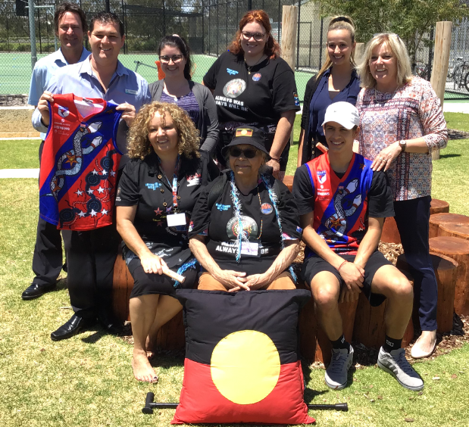
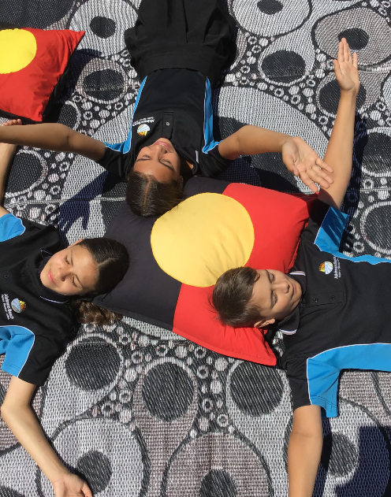
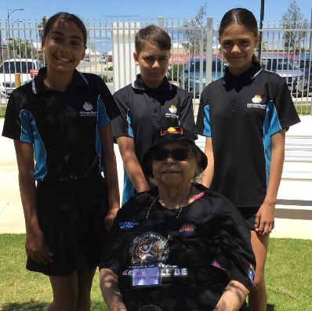
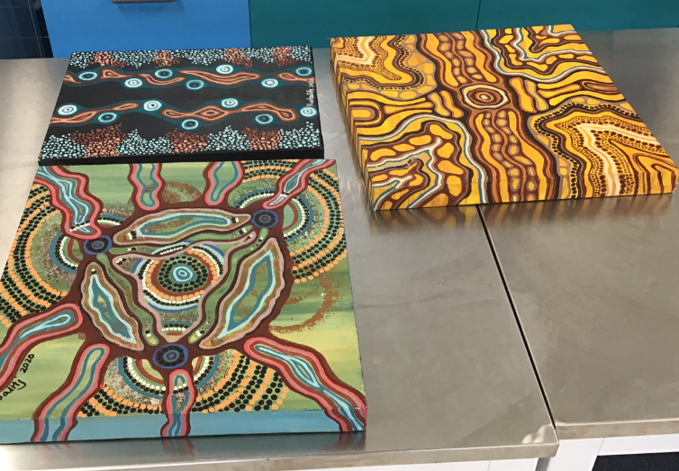
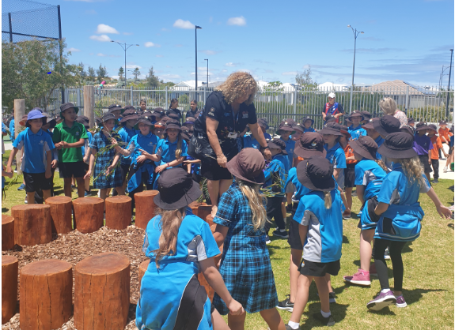
Alkimos Beach Primary School students and staff recently participated in an art project with the Djinda Bridiya Wellbeing Australian Aboriginal Corporation on
Thursday, November 12th. The visitors included the founder of the organisation, Sharon Wood-Kenney, her daughter Paige, Elder Doreen Green and Kaide Wheelock.

The visitors led a session on Aboriginal culture whereby they shared culturally and significant stories and dances with the year 4 students as well as performing a smoking ceremony. This led to an art workshop with the year 4 students. He art pieces created by the students captured elements of the six Nyoongar seasons and will be collated with other art from schools in the Alkimos Community.

The combined art will eventually be installed as part of the Metro Net artwork on the eastern side of Marmion Avenue, north of the future Romeo Road connection for the community to view and appreciate.

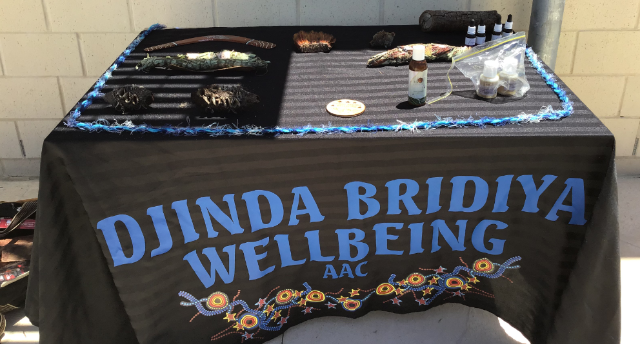

STUDENTS NOT RETURNING IN 2021

We are currently looking at student numbers for next year. If your student will not be returning to Alkimos Beach Primary School in 2021 please see the office to complete a notification form. Alternatively, please email your notification (with all the following details) to alkimosbeach.ps@education.wa.edu.au.

- Student’s full name
- Year/Form
- Last date attending
- Name of school they will be attending in the future
- Reason for leaving

UP IN LIGHTS

Mrs McComish – Kindy D

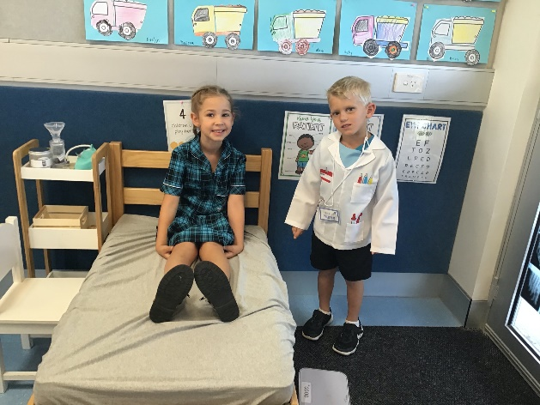
What a magical time in Kindy with Mrs McComish. These lucky students have been immersing themselves in all things Possum Magic, the beautiful picture book by Mem Fox. They have also been learning about retells of stories, as well as name and number writing. The highlight of their year has been learning how to cope with change and how to be resilient. The students have loved playing with rice, using play-doh, collage, blocks and art and craft. Interviewing and Photography by Fourie and Chloe
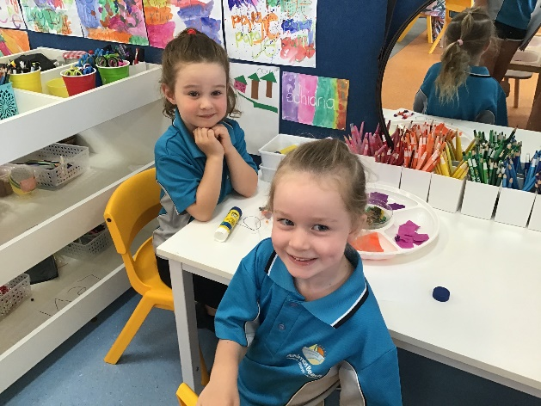
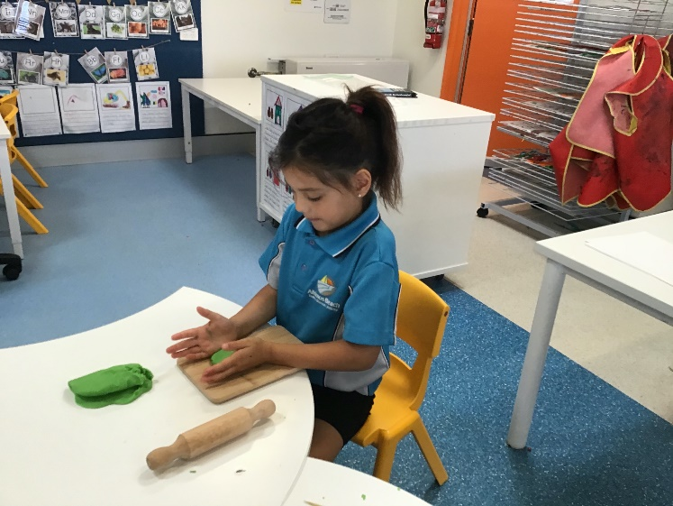
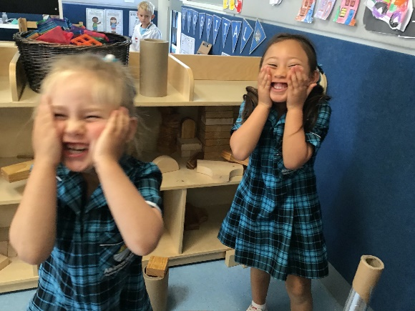

Mrs Erasmus - Kindy E

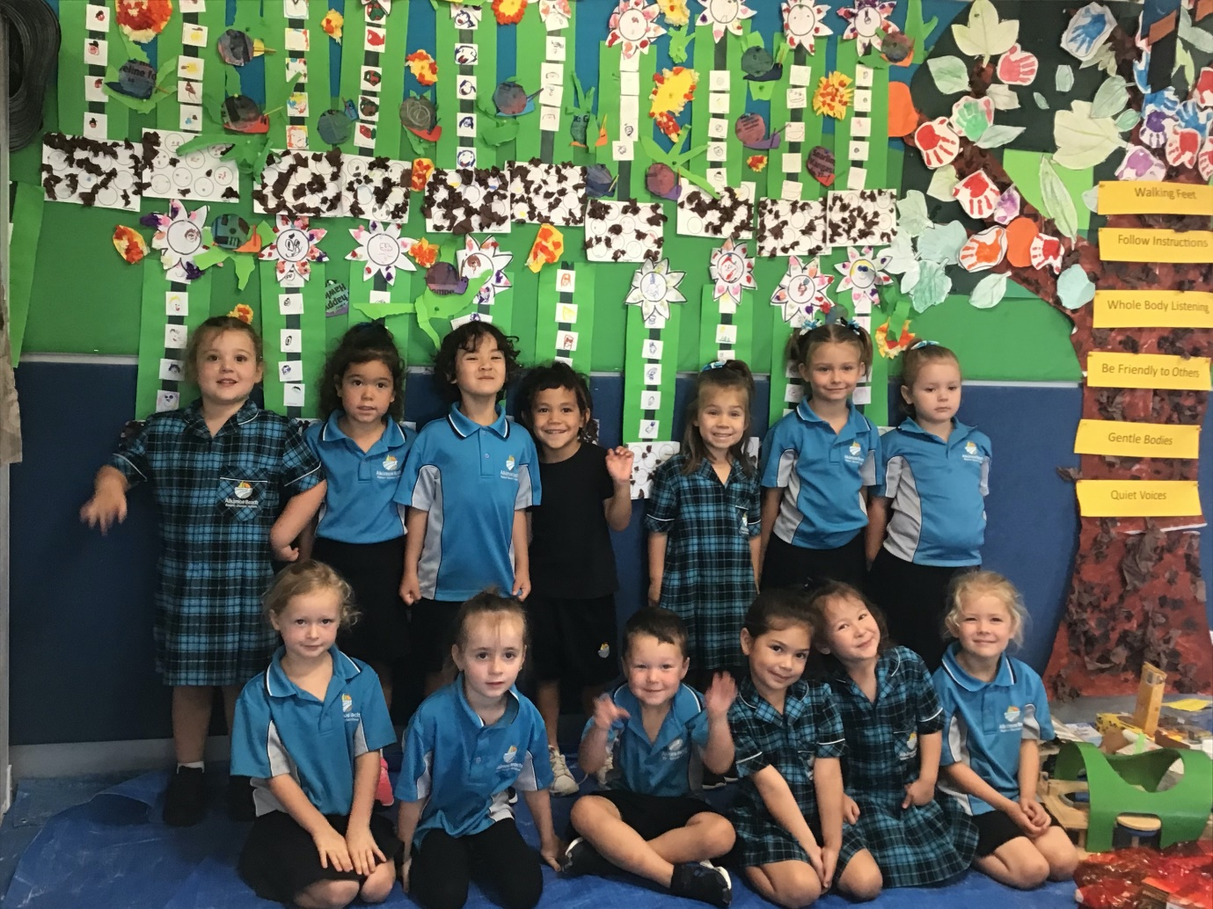
What a perfect way to spend Term 4, in learning all about friendship. These Kindy students created a beautiful friendship garden to have in their room; if they are feeling sad, these Kindy kids can go to their garden and a friend will come along and cheer them up. The flowers mean friends; the snails mean that they are feeling bad and the stems make you strong. The whole class “loves school” and they all “love learning”. What a lucky class. Interviewing and Photography Aiden and Evie

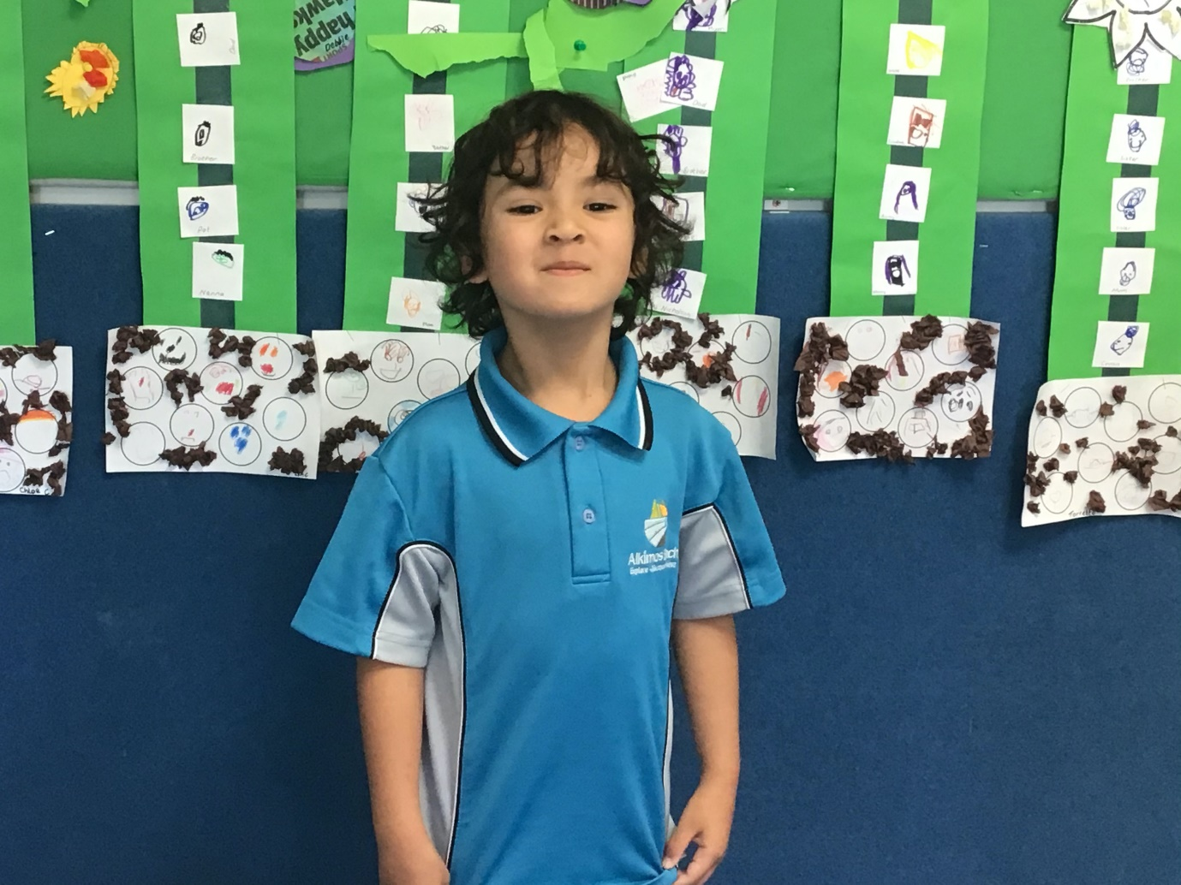
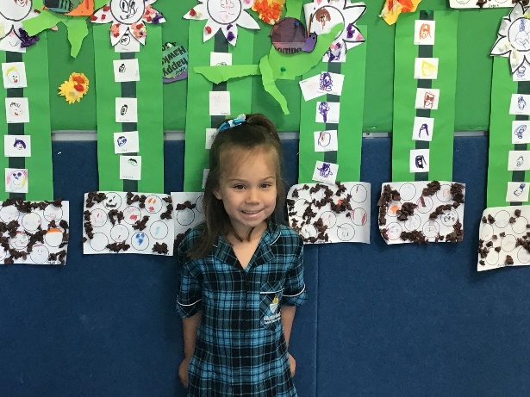
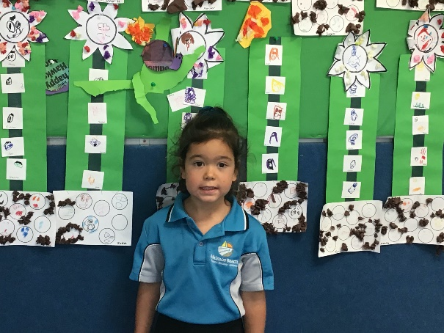

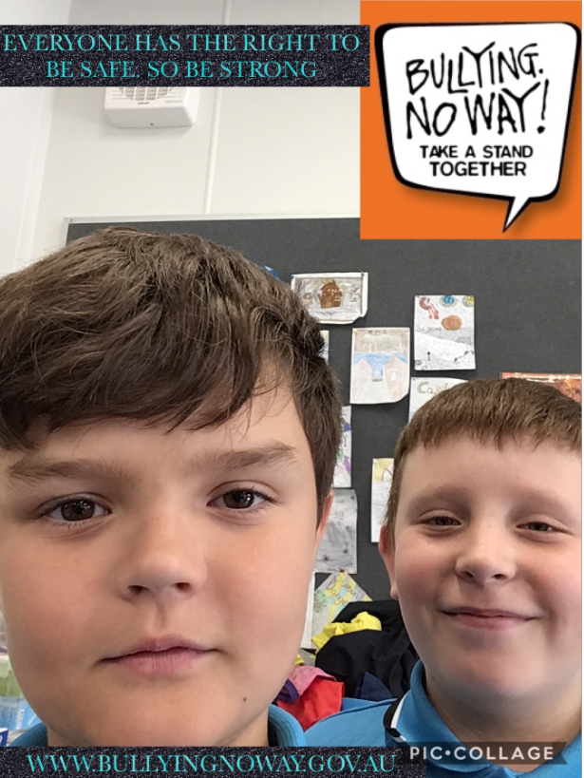
Bullying... NO WAY!

